INFO-6068 Status Meeting Minutes – Team Pro-Test

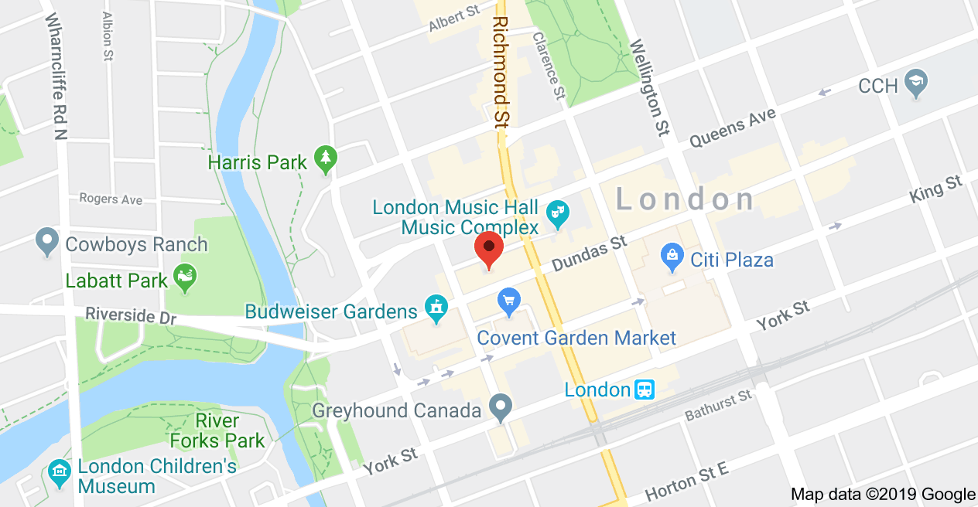

|  |  |  |  |
| --- | --- | --- | --- |
| Project: |  | | |
| **Project Manager:** | Francisco Gomez | **Business Responsible:** |  |
| Date: | 12-Sep-2019 | **Phase:** |  |
| Time: | 6:00pm | Location: | Fanshawe Downtown Campus – Room 415  130 Dundas Street  London ON |
| Prepared by: | Ralph Anonuevo | Schedule: | **From:** 6:00pm  **To:** 7:00pm |

| Attendees (Present, Absent) | | | | | |
| --- | --- | --- | --- | --- | --- |
| Invited | Attended | Invited | Attended | Invited | Attended |
| Francisco Gomez | **√** |  |  |  |  |
| Ralph Anonuevo | **√** |  |  |  |  |
| Lyan Joy Limjap | **√** |  |  |  |  |
| Daniel Gilbert | **√** |  |  |  |  |
| Mrinal Chopra | **√** |  |  |  |  |
| Rose Maria George | **√** |  |  |  |  |

| Objective(s): |
| --- |
| 1. Review Current Project Activities 2. Next Steps 3. General Discussion 4. Define Procedures for Rotating Manager and Scribe roles 5. Discuss Project Plan Initiation 6. Establish Main forms of communication |

| Agenda/Meeting Highlights | |
| --- | --- |
| Topic # | Agenda/Meeting Highlights: |
|  | Communication will be done via WhatsApp and Gmail |
|  | Rotation for the manager and scribe roles every week. |
|  | Have a proof reading after the work (Quality Analysis) |
|  | Deadline for every task will be 2 to 3 days prior to submission. |
|  | Wednesday 4pm is the establishing meeting time. Possible meeting at Monday 11am. |
|  | Using zoom for physical absence |
|  | Daniel will be the technical lead for September 12, 2019. |
|  | Introduction for new member Rose and Mrinal |
|  | Creating a draft for project plan that due on September 19,2019 |
|  | Update the IAD log for every week. |

| Action/Issues List | | | | | |
| --- | --- | --- | --- | --- | --- |
| # | Date | Actions | Owner | Target Date | Action Status |
|  | 09-12-19 | Fransico created a tactical role for manager and scribe | Project Manager | 09-12-19 | Closed |
|  | 09-12-19 | Prepare Agenda for next meeting | Scribe | 09-16-19 | Open |
|  | 09-12-19 | Update the Project plan draft | Project Manager | 09-19-19 | Open |
|  | 09-12-19 | Update Final Project Plan | Project Manager | 12-05-19 | Open |
|  |  |  |  |  |  |
|  |  |  |  |  |  |
|  |  |  |  |  |  |
|  |  |  |  |  |  |
|  |  |  |  |  |  |
|  |  |  |  |  |  |
|  |  |  |  |  |  |
|  |  |  |  |  |  |

| Next Meeting | | |
| --- | --- | --- |
| Date | Room | Duration |
| September 16, 2019 | Room 415 | 1 hour |